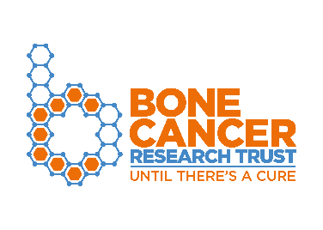

Patient and Public Involvement (PPI)
Support request form for researchers
The Bone Cancer Research Trust is committed to support the best quality research that has the potential to improve outcomes and benefit people affected by primary bone cancer.
Before completing this form, we recommend you read our PPI researchers handbook.
Please return your completed form to research@bcrt.org.uk

Disclaimer: Please note that by helping you to involve people affected by primary bone cancer in developing your research applications, the Bone Cancer Research Trust does not take responsibility for the research and is therefore not liable for any claims of negligence, harm or oversight connected to it.

Contact details
Principal applicant
Position
Research Institution & Department
Phone number
Email
Co-applicants (please also include their affiliation)
Collaborators (please also include their affiliation)
Where did you hear about our PPI support?

Research details
Application title
Plain English title
Plain English description of the study and its aims (max 250 words, including research area, type of primary bone cancer and any suitable links to online information about the research that can be suitable for lay members of our PPI panel)
How could this project improve treatment options for people affected by primary bone cancer? (in ~100 words)
What stage are you currently at with your research? Have you secured funding for your research? If yes, who is the funder? If no, when, and where are you applying for funding?

PPI in your research
At what stage of your research would you like to involve people affected by primary bone cancer (Select all that apply)
☐ Identifying and prioritising your research question
☐ Writing your plain English summary
☐ Designing your study
☐ Evaluating study documents (information sheets, consent forms etc.)
☐ Managing the research (as part of a steering group or advisory committee)
☐ Undertaking the research
☐ Disseminating the research
☐ Evaluating impact
☐ Other (please specify):
How would you like to involve people affected by primary bone cancer in your project? (For example, completing a survey, attending focus/steering groups, reviewing documentation)
When would you like the PPI activity/activities to start? | When would you need the PPI activity/activities to be completed?
PPI in your research - who are you looking to involve?
Are you looking for people affected by a specific type of primary bone cancer? (Please specify)
PPI in your research - ethics and payment
The Bone Cancer Research Trust aims to ensure all PPI activities are carried out in an ethical way; however, please note that ethical approval is not required for PPI consultations.
All members of the Bone Cancer Research Trust PPI panel act on a voluntary capacity. Consultations will be organised by email and teleconference and will be facilitated by BCRT’s research team.
Your experience of patient and public involvement
Do you have previous experience of patient and public involvement? | ☐ No previous experience  ☐ A little experience  ☐ Some experience  ☐ Significant experience
Please provide a brief description of any previous involvement experience:
Feedback and acknowledgement
How do you plan to feedback to the PPI contributors on the impact they have had?
How will you inform PPI contributors of the research outcomes once the study is complete?
How do you plan to acknowledge the PPI contributors?

If you have any further questions about our PPI programme, please contact the research team at research@bcrt.org.uk.

